

**Module Code & Module Title:**

**CS5002NT Software Engineering**

**Assessment Weightage & Type:**

**20% Group Coursework**

**Title:   
Darpan Dental Home Application**

**Year and Semester:**

**2019-20 Autumn**

|  |  |  |  |
| --- | --- | --- | --- |
| **Group Name: (GRSST5)** | | | |
| **SN** | **Student Name** | **College ID** | **University ID** |
| **1** | **Girija Tamang** | **NP05CP4S190007** | **18030995** |
| **2** | **Rikesh Niroula** | **NP05CP4A180047** | **18028923** |
| **3** | **Samip Danuwar** | **NP05CP4A180089** | **18028965** |
| **4** | **Susan Adhikari** | **NP05CP4A180071** | **18028947** |
| **5.** | **Tej Narayan Chaudhary** | **NP05CP4A180092** | **18028969** |

*I confirm that I understand my coursework needs to be submitted online via Google Classroom under the relevant module page before the deadline in order for my assignment to be accepted and marked. I am fully aware that late submissions will be treated as non-submission and a mark of zero will be awarded.*

**ACKNOWLEGEMENT**

In the present world of competition there is a race of existence in which those are having will to come forward succeed. Project is like a bridge between theoretical and practical working. With this willing this project is given to ours group.

We are feeling oblige in talking the opportunity to sincerely thanks to our module leader Mr. Mission Babu Sapkota. Without his effort this project could not become a reality. Next to him are always our family whom we are greatly indebted for us brought up with love and encouragement to this stage.

At last but not the least we are thankful to all our friends who have been always helping and encouraging to us throughout the year. We have no valuable words to express our thanks, but our heart is still full of the favors received from every person.

**CONTENTS**

**1** **INTRODUCTION** 1

**1.1 AIMS AND OBJECTIVES** 2

**1.2** **TOOLS AND TECHNIQUES:** 3

**2** **GROUP TASK** 5

**2.1 ENVIRONMENTAL MODEL SPECIFICATION:** 5

**2.1.1 Statement of Purpose** 5

**2.1.2 Event List** 6

**2.1.3 Context Diagram** 7

**2.2 INTERNAL MODEL SPECIFICATION:** 9

**2.2.1 DFD Fragments** 9

**2.2.2 Data Flow Diagram:** 27

**2.2.3 Entity Relationship Diagram:** 29

**2.2.4 Data Dictionary:** 34

**2.3 DESIGN SPECIFICATION** 41

**2.3.1 Structure Chart of Darpan Dental Home Application** 41

**2.4 ASSIGNMENT DIARY** 42

**3** **INDIVIDUAL TASK** 44

**3.1 Register a Patient Function** 44

**3.1.1 Environmental Module Specification** 44

**3.1.2 Internal Module Specification** 45

**3.1.3 Level 2 DFD** 46

**3.1.4 Design Specification** 47

**3.2 Payment of Patient Function** 49

**3.2.1 Environmental Module Specification** 49

**3.2.2 Internal Module Specification** 50

**3.2.3 Level 2 DFD** 51

**3.2.4 Design Specification** 52

**3.3 Book Appointment** 54

**3.3.1 Environmental Module Specification** 54

**3.3.2 Internal Module Specification** 55

**3.3.3 Level 2 DFD** 56

**3.3.4 Design Specification** 57

**3.4 De-Register Staff** 59

**3.4.1 Environmental Module Specification** 59

**3.4.2 Internal Module Specification** 60

**3.4.3 Level 2 DFD** 61

**3.4.4 Design Specification** 62

**3.5 Generate Report of Patient** 63

**3.5.1 Environmental Module Specification** 63

**3.5.2 Internal Module Specification** 64

**3.5.3 Level 2 DFD** 65

**4** **SUMMARY** 68

**5** **REFERENCES** 69

**TABLE OF FIGURES**

Figure 1 MS Word 3

Figure 2 Draw.io 4

Figure 3: Context Diagram of Darpan Dental Home Application 7

Figure 4 Event List Fragmentation of Keeping Appointment Details 9

Figure 5 Event List fragmentation of keeping the Record of Patient 10

Figure 6 Event List fragmentation of Generates the report of Patients 11

Figure 7 Event List fragmentation of appointing the staff in dental home 12

Figure 8 Event List fragmentation of checking the contact details of Staff 13

Figure 9 Event List fragmentation of de-register the staff 14

Figure 10 Event List fragmentation of staff register in the system after approval of admin 16

Figure 11 Event List fragmentation of Staff logs in the system 18

Figure 12 Event List fragmentation of Staff checks the forms after verifaction 19

Figure 13 Event List fragmentation of Staff records the patient details 21

Figure 14 Event List fragmentation of Staff sets the notice and discount message 22

Figure 15 Event List fragmentation of Patient details for registration 23

Figure 16 Event List fragmentation of patient book the appointment 25

Figure 17 Event List fragmentation of Patient makes payment 26

Figure 18: Data Flow Diagram of Darpan Dental Home Application 27

Figure 19: Entity Relationship Diagram of Darpan Dental Home Application 29

Figure 20: Entities used in Entity Relationship Diagram 30

Figure 21: Entity Admin and its attributes 31

Figure 22: Entity Admin and its attributes 31

Figure 23: Entity Staff and its attributes 32

Figure 24: Entity Report and its attributes 32

Figure 25: Entity Payment and its attributes 33

Figure 26: Entity Book Appointment and its attributes 33

Figure 27: Structure chart of Darpan Dental Home Application 41

Figure 28: Context Diagram of Register of Patient 44

Figure 29: Level 1 DFD of Register of Patient 45

Figure 30: Level 2 DFD of Register of Patient 46

Figure 31: Structure Chart of Register of Patient 47

Figure 32: Context Diagram of Payment of Patient 49

Figure 33: Level 1 DFD of Payment of Patient 50

Figure 34: Level 2 DFD of Payment of Patient 51

Figure 35: Structure Chart of Payment of Patient 52

Figure 36 Book Appointment Context Diagram 54

Figure 37 Book Appointment Level 1 DFD 55

Figure 38 Book Appointment Level 2 DFD 56

Figure 39 Book Appointment Design Specification 57

Figure 40 De-Register Staff Context Diagram 59

Figure 41 De-Register Level 1 DFD 60

Figure 42 De-Register Staff Level 2 DFD 61

Figure 43 De-Register Staff Design Specification 62

Figure 44 Generate Report of Patient Context Diagram 63

Figure 45 Generate Report Level 1 DFD 64

Figure 46 Generate Report Level 2 DFD 65

Figure 47 Generate Report of Patient Design Specification 66

**TABLE OF TABLES**

Table 1 Process Specification of Keeping Appointment Details 10

Table 2 Process Specification of Admin keeps record of patient 11

Table 3 Process Specification of Generate the report of patient 12

Table 4 Process Specification of Appointment record of staff 13

Table 5 Process Specification of Checking the contact 14

Table 6 Process Specification of De-Register of Staff 15

Table 7 Process Specification of Staff Register 17

Table 8 Process Specification of Login the staff 18

Table 9 Process Specification of checks the patient details 20

Table 10 Process Specification of Record Patient Details 21

Table 11 Process Specification of Message Discount 22

Table 12 Process Specification of Register details of patient 24

Table 13 Process Specification of Booking Appointment 25

Table 14 Process Specification of Payment of the patinet 26

Table 15: Data Dictionary of Patient table 34

Table 16: Data Dictionary of Record table 35

Table 17: Data Dictionary of Register table for Patient 35

Table 18: Data Dictionary of Admin Table 36

Table 19: Data Dictionary of Report Table 36

Table 20: Data Dictionary of Staff Table 37

Table 21: Data Dictionary of Staff Registration 37

Table 22: Data Dictionary of Contract Table 38

Table 23: Data Dictionary of Restriction Table 38

Table 24: Data Dictionary of Book Appointment Table 39

Table 25: Data Dictionary of Deadline Table 40

Table 26: Group Meeting Date Table 42

Table 27: Group responsibilities Table 43

# **INTRODUCTION**

This project is all about formulating a system of health-related application for the dental hospital named ‘Darpan Dental Home’. This system helps in keeping the records of the patient with their personal information like date of birth, age and name. Here, the payment method and the details of the payment done by patient is also recorded systematically. Appointment system is also made in this system.

Patient’s records like name of patient, age of patient, and username, and password, address of patient, payment amount, and date of registration are stored in this system. Here, for the appointment, the patient can register his/her information. If they do not appear in hospital even after six months of appointment, they are reminded to visit hospital. Staffs helps to maintain the record of payment and the types of payment. Staffs are responsible to make the appointment time and follow-up time. Admin of this application is are responsible for creating the final report. Even, through this system patient can update their appointment time and follow-up time.

From the help of those records, the designing of context level diagram, data flow diagram, structure chart and data dictionary along with ER Diagram and pseudocode are built.

## **1.1 AIMS AND OBJECTIVES**

Every project is designed with purpose of some aims, motto and some objectives. Here, this project is also glorified and designed with the purpose of some aims and objectives. The aims and objectives of this project are as follows:

* To formulate Darpan Dental Home Application.
* To make the records of the information of patient systematic, secure and eligible to display while searching.
* To check whether the patient makes a payment or not.
* To get lower level knowledge on contextual diagram, structured diagram, process specification, data dictionary, data flow diagram, ER diagram of this project.
* To minimize the problem of Darpan Dental Home.
* To help patient in their appointment timing date and follow-up timing date.

## **TOOLS AND TECHNIQUES:**

There are various tools which is used to complete this project. Some of them are Microsoft Word which was used for documentation, draw.io for designation of ER diagram, contextual Diagram, Structured Chart, data flow diagram and data dictionary. The brief overview about them are given below:

**MS Word**

In MS-Word we are able to create a report describing about the project ‘Darpan Dental Home Application’ that we have made. Its features have made us easier to make a report on our project. Using MS-Word we have created Data Dictionary Table and so on. It helped a lot to complete the project.



Figure 1 MS Word

**DRAW.IO**

In draw.io, we can create all the context diagram, Data Flow Diagram, Structure Chart. It helped a lot to complete the ‘Darpan Dental Home Application’ project in a specified time.

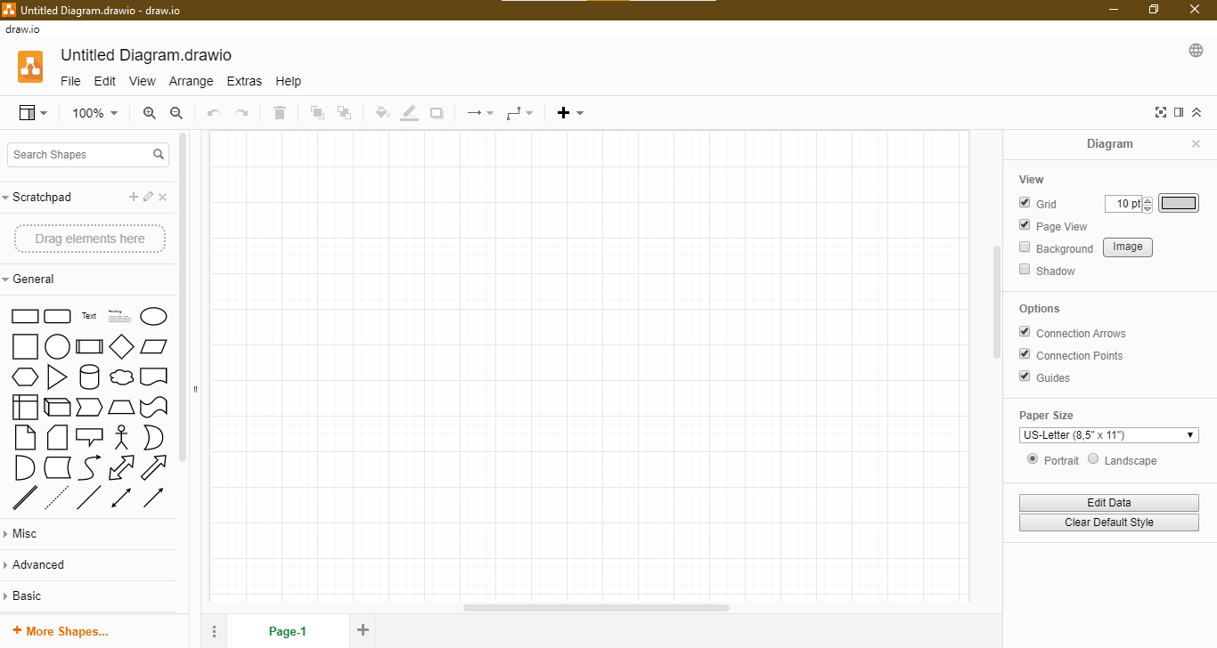

Figure 2 Draw.io

# **GROUP TASK**

## **2.1 ENVIRONMENTAL MODEL SPECIFICATION:**

### **2.1.1 Statement of Purpose**

The main purpose of the project is to provide a digitalized system for a Dental Clinic named as Darpan Dental Home. The digitalized system will help the clinic to minimize all the problems that are being faced by the clinic. It will help the clinic in different ways like: maintaining records of the patients, their payment details, generating report, keeping track of the patients and staffs, making the works easy and convenient for the clinic.

As in the past, the clinic has faced a lot of problems regarding managing, maintaining records of the patients. But using this system the clinic would be free from those problems. As the system keeps all the tracks of their patients and staffs. The system is so convenient that if a patient does not visit clinic for six months it will automatically send a reminder message to the patient. Anyone can use the system but first he/she should be registered to Darpan Dental Home Clinic.

### **2.1.2 Event List**

Here are some event list regarding Darpan Dental Home Application. They are as follow:

**For Admin**

* Admin keeps appointment details of patient.
* Admin keeps record of patient.
* Admin generates the report of patient.
* Admin appoint the staff in Dental Home.
* Admin checks contract details of staff.
* Admin can de register the staff.

**For Staff**

* Staff are registered in the system after the approval of admin.
* Staff logs in the system.
* Staff checks the forms and verify the patient.
* Staff records the patient details
* Staff sets the notice and discount message.

**For patient**

* Patient gives his/her details for registration.
* Patient book the appointment.
* Patient makes payment.

### **2.1.3 Context Diagram**

The context diagram is a diagram that is used for establishment of context and boundaries of the system to be made. It shows the relationship of system to the external entities also things that are inside and outside of the system which is being made.

It is a high-level process and also known as zero level data flow diagram that is drawn in order to define and clarify the boundaries of the system software. It shows entire software as a single process and identifies the flows of information between the system and external entities.

(MSCIT Study Material, 2011)

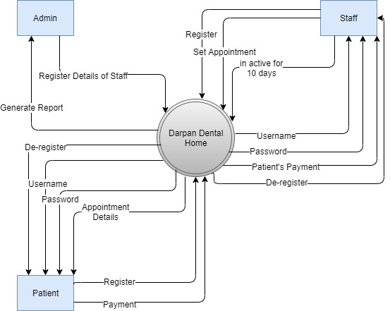

Figure 3: Context Diagram of Darpan Dental Home Application

**Diagram Description**

The above figure shows overall context diagram of Darpan Dental Home Application. It shows that the software consists of two external entities that are Staff and Patient.

The external entity Patient provides patient information and payment details on a system and in return system provides patient username, password and appointment details. If the patient doesn’t attend the appointment for long interval, then the system could cancel or de-register the patient.

Similarly, the external entity Staff provides staff information, sets appointment details for the patient on the system. While the system provides staff username, password and payment of the patients. And, if the staff has not attended any appointment for a long time then the staff could be de- register too.

Similarly, admin register details of all patients and staffs to the system and receives report of the staffs and patients.

# **2.2 INTERNAL MODEL SPECIFICATION:**

### **2.2.1 DFD Fragments**

**For Admin**

**Admin Keep Appointment Details of Patients**

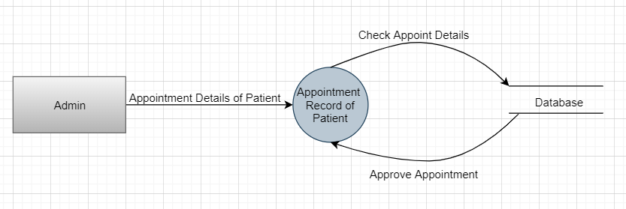

Figure 4 Event List Fragmentation of Keeping Appointment Details

From the above figure, we can see that patient is appoint, Involves in Appointment Record of the Patient. First, Appointment Details of Patient, and their data are check and approve and record in Database.

**Process Specification**

Table 1 Process Specification of Keeping Appointment Details

|  |  |
| --- | --- |
| **Process Name** | Keep Appointment Details of Patient. |
| **Description** | Admin Appoints Patient |
| **Input data Flow** | Appointment Details of Patient |
| **Output Data Flow** | Approve Appointment |
| **Pseudocode** | INPUT Appoint request  Do  Ask to Appointment Details of Patient?  IF(YES)  Check Appointment Details  Approve Appointment  ELSE  Unapproved Appointment |

**Admin Keep Record of Patient**

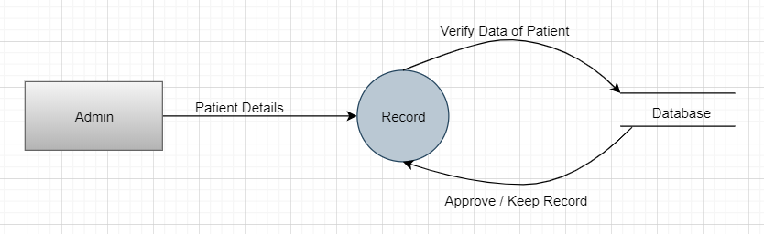

Figure 5 Event List fragmentation of keeping the Record of Patient

From the above Figure, we can see that Patient Record are Recorded in database, Involves in Record of Application. Frist, Patent Details, and their data are verifying and Approve and keep Record.

**Process Specification**

Table 2 Process Specification of Admin keeps record of patient

|  |  |
| --- | --- |
| **Process Name** | Keep Record of Patient. |
| **Description** | Record the Patient Detail |
| **Input data Flow** | Patient Detail |
| **Output Data Flow** | Approve / keep Record |
| **Pseudocode** | INPUT Patient Details  Do  Ask to Verify Data of Patient?  IF(YES)  Verify the Data of Patient  Approve /Keep Record  ELSE  Unapproved Record |

**Admin generates the report of Patients**

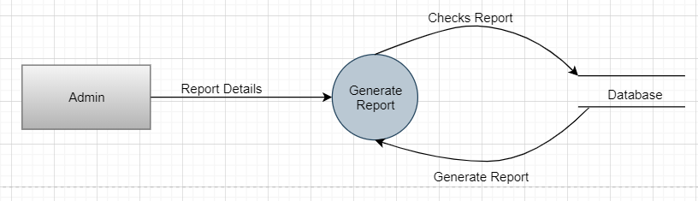

Figure 6 Event List fragmentation of Generates the report of Patients

From the above figure, we can see that Report is Generated, involves in generates the report of patients. First, Report details for Generating the report, and their report are checks and Generated the report.

**Process Specification:**

Table 3 Process Specification of Generate the report of patient

|  |  |
| --- | --- |
| **Process Name** | Generate the report of Patients |
| **Description** | Generate the Patient Report |
| **Input data Flow** | Report Detail |
| **Output Data Flow** | Generate Report |
| **Pseudocode** | INPUT Report Details  Do  Ask to Check Report?  IF(YES)  Check the Report of Patient  Generate Report  ELSE  Un Generate Report |

**Admin Appoint the staff in Dental Home**

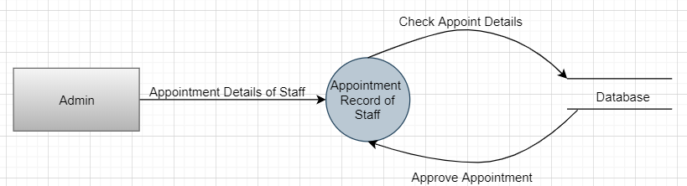

Figure 7 Event List fragmentation of appointing the staff in dental home

From the above figure, we can see that Appointment Record of Staff, Involves in Appointment Record of Staff. First, Appointment Details of Staff for Appointment Record of Staff, and their Appointment Details are checks and Approve Appointment.

**Process Specification:**

Table 4 Process Specification of Appointment record of staff

|  |  |
| --- | --- |
| **Process Name** | Appointment Record of Staff |
| **Description** | Admin Appoint the Staff |
| **Input data Flow** | Appointment Details of Staff |
| **Output Data Flow** | Appointment Record of Staff |
| **Pseudocode** | INPUT Appointment Details of Staff  Do  Ask to Check Appoint Details?  IF(YES)  Check the Appoint Details  Approve Appointment  ELSE  Unappoint the Staff |

**Admin Checks contact details of Staff**

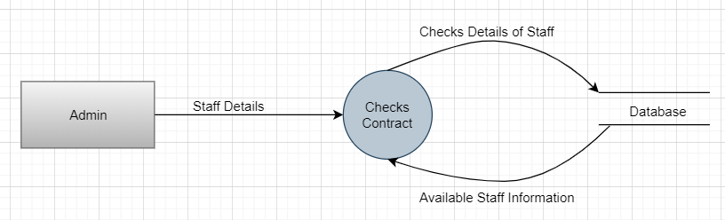

Figure 8 Event List fragmentation of checking the contact details of Staff

From the above figure, we can see that Checks Contact, Involves in Checks Contact. First, Staff Details for Checks Contact, and their Staff Details are checks and Available Staff Information.

**Process Specification**

Table 5 Process Specification of Checking the contact

|  |  |
| --- | --- |
| **Process Name** | Checks Contact |
| **Description** | Admin Checks Contact |
| **Input data Flow** | Staff Details |
| **Output Data Flow** | Available Staff Information |
| **Pseudocode** | INPUT Staff Details  Do  Ask to Check Details of Staff?  IF(YES)  Check Details of Staff  Available Staff Information  ELSE  Un Checks Staff Information |

**Admin can De-register the staff**

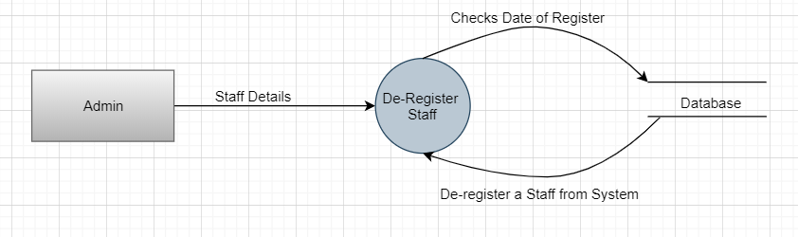

Figure 9 Event List fragmentation of de-register the staff

From the above figure, we can see that De-Register Staff, Involves in De-Register the Staff. First, Staff Details for De-Register Staff, and their Checks Date of Register and De-Register a Staff from Staff.

**Process Specification:**

Table 6 Process Specification of De-Register of Staff

|  |  |
| --- | --- |
| **Process Name** | De-Register of Staff |
| **Description** | Admin De-Register the Staff |
| **Input data Flow** | Staff Details |
| **Output Data Flow** | De-Register a Staff from System |
| **Pseudocode** | INPUT Staff Details  Do  Ask to Check Date of Register?  IF(YES)  Check Details Date of Register  De-Register a Staff from System  ELSE  Un De-Register a Staff from System |

**FOR STAFF**

**Staff are registered in the system after the approval of admin.**

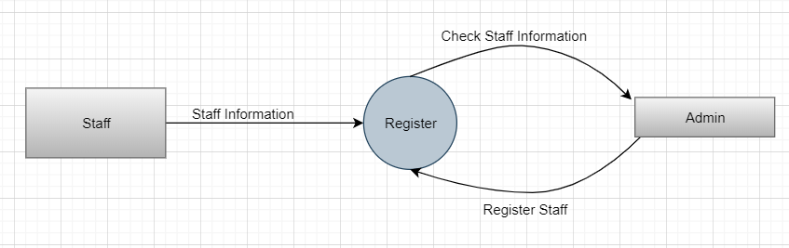

Figure 10 Event List fragmentation of staff register in the system after approval of admin

From the above figure, we can see that Register Staff, Involves in Register Staff. First, Staff Information, and their Checks Staff Information and Register Staff.

**Process Specification:**

Table 7 Process Specification of Staff Register

|  |  |
| --- | --- |
| **Process Name** | Staff Register |
| **Description** | Register |
| **Input data Flow** | Staff Information |
| **Output Data Flow** | Register Staff |
| **Pseudocode** | INPUT Staff Information  Do  Ask to Check Staff Information?  IF(YES)  Check Staff Information  Register Staff  ELSE  Un Register Staff |

**Staff logs in the system.**

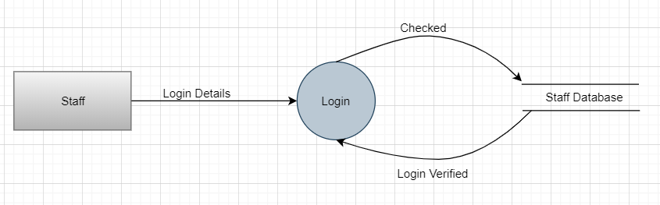

Figure 11 Event List fragmentation of Staff logs in the system

From the above figure, we can see that Staff Login, Involves in Login Staff. First, Login Details for Staff Login, and their Checked Login Details and Login Verified.

**Process Specification**

Table 8 Process Specification of Login the staff

|  |  |
| --- | --- |
| **Process Name** | Login Staff |
| **Description** | Login |
| **Input data Flow** | Login Details |
| **Output Data Flow** | Login Details |
| **Pseudocode** | INPUT Login Details  Do  Ask to Checked Login Details?  IF(YES)  Checked Login Details  Login Verified  ELSE  Un Login Staff |

**Staff checks the forms and verify the patient.**

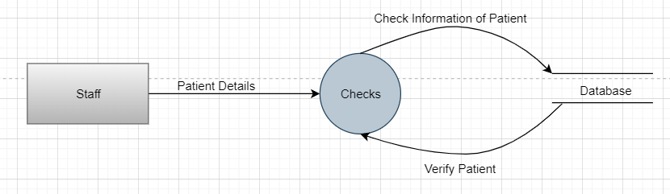

Figure 12 Event List fragmentation of Staff checks the forms after verifaction

From the above figure, we can see that Checks Patient Details, Involves in Checks Patient Details. First, Patient Details for Check Patient Details, and their Check Information of Patient and Verified Patient.

**Process Specification**

Table 9 Process Specification of checks the patient details

|  |  |
| --- | --- |
| **Process Name** | Checks Patient Details |
| **Description** | Checks |
| **Input data Flow** | Patient Details |
| **Output Data Flow** | Verified Patient |
| **Pseudocode** | INPUT Patient Details  Do  Ask to Check Information of Patient?  IF(YES)  Check Information of Patient  Verified Patient  ELSE  Un Verified Patient |

**Staff records the patient details**

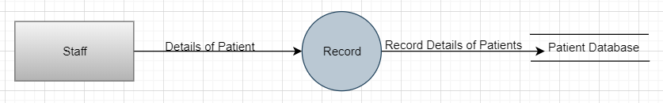

Figure 13 Event List fragmentation of Staff records the patient details

From the above figure, we can see that Record of Patient, Involves in Record the Staff Details. First, Details of Patient For Record the Patient Details, and their Checks Record Details of the Patient For Record and Record the Patient By Staff.

**Process Specification**

Table 10 Process Specification of Record Patient Details

|  |  |
| --- | --- |
| **Process Name** | Record Patient Details |
| **Description** | Record |
| **Input data Flow** | Details of Patient |
| **Output Data Flow** | Record Details of Patient |
| **Pseudocode** | INPUT Details of Patient  Do  Ask to Check Record Details of Patient?  IF(YES)  Check Record Details of Patient  Record Details of Patient  ELSE  Un Record the Patient Details |

**Staff sets the notice and discount message.**

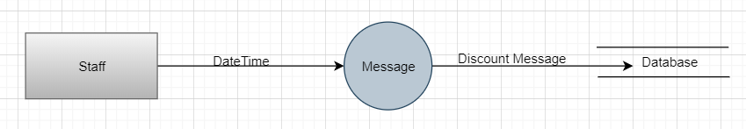

Figure 14 Event List fragmentation of Staff sets the notice and discount message

From the above figure, we can see that Message of Discount, Involves in Message of Discount. First, Date Time of staff, and their Checks Date Time of Staff Appoint and Message Discount.

**Process Specification**

Table 11 Process Specification of Message Discount

|  |  |
| --- | --- |
| **Process Name** | Message Discount |
| **Description** | Message |
| **Input data Flow** | Date Time |
| **Output Data Flow** | Discount Message |
| **Pseudocode** | INPUT Date Time  Do  Ask to Check Discount Message?  IF(YES)  Check Discount Message  Discount Message  ELSE  Un Message Discount |

**FOR PATIENT**

**Patient gives his/her details for registration.**

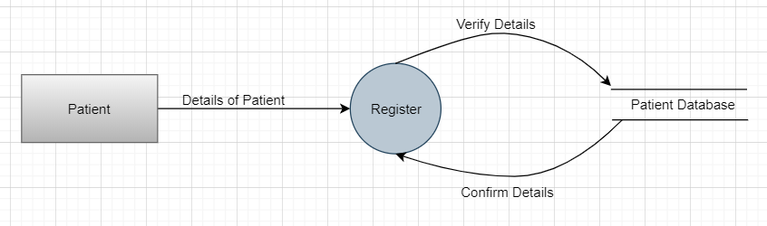

Figure 15 Event List fragmentation of Patient details for registration

From the above figure, we can see that Register Patient Details, Involves in Register of Patient Details. First, Details of the Patient for Register, and their Verify the Details of Register and Confirm Details of Patient.

**Process Specification:**

Table 12 Process Specification of Register details of patient

|  |  |
| --- | --- |
| **Process Name** | Register Details of Patient |
| **Description** | Register |
| **Input data Flow** | Details of Patient |
| **Output Data Flow** | Confirm Details |
| **Pseudocode** | INPUT Details of Patient  Do  Ask to Verify Details of Patient?  IF(YES)  Verify the Details of Patient  Confirm the Details  ELSE  Un Confirm Details |

**Patient book the appointment.**

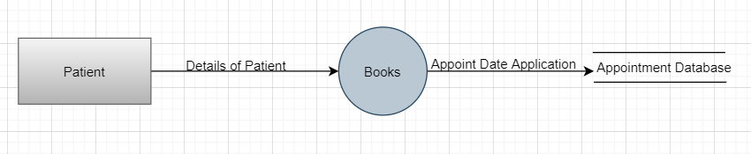

Figure 16 Event List fragmentation of patient book the appointment

From the above figure, we can see that Book Appointment, Involves in Appointment Book. First, Details of the Patient for Book Appointment, and their Checks Details of Patient and Appoint Date of Application.

**Process Specification**

Table 13 Process Specification of Booking Appointment

|  |  |
| --- | --- |
| **Process Name** | Book Appointment |
| **Description** | Books |
| **Input data Flow** | Details of Patient |
| **Output Data Flow** | Appoint Date Application |
| **Pseudocode** | INPUT Details of Patient  Do  Ask to Check Appoint date Application?  IF(YES)  Check Appoint Date Application  Appoint Date Application  ELSE  Un Appoint Date Application |

**Patient makes payment.**

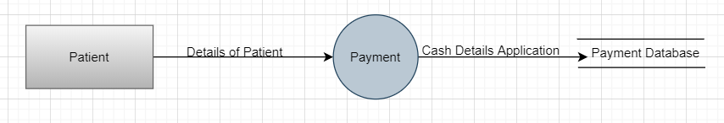

Figure 17 Event List fragmentation of Patient makes payment

From the above figure, we can see that Payment of the Patient, Involves in Payment of the Patient. First, Details of Patient for Payment, and their Checks Payment of the Patient and Cash Details Application of Patient.

**Process Specification**

Table 14 Process Specification of Payment of the patinet

|  |  |
| --- | --- |
| **Process Name** | Payment of the Patient |
| **Description** | Payment |
| **Input data Flow** | Details of Patient |
| **Output Data Flow** | Cash Details Application |
| **Pseudocode** | INPUT Details of Patient  Do  Ask to Check Payment of the Patient Application?  IF(YES)  Checks Payment of the Patient Application  Cash Details Application  ELSE  Un Cash Details Application |

### **2.2.2 Data Flow Diagram:**

DFD is a graphical representation of flow of data in a business information system. It describes the process that are involved in a system to transfer data from the input to the file storage and report generation. It represents the functions, process, which capture manipulate, store and distribute data between a system and its environment and between components of a system. It can be manual, automated as per the systems requirements and makes a good communication tool between user and system designer.

(Visual Paradigm, 2020)

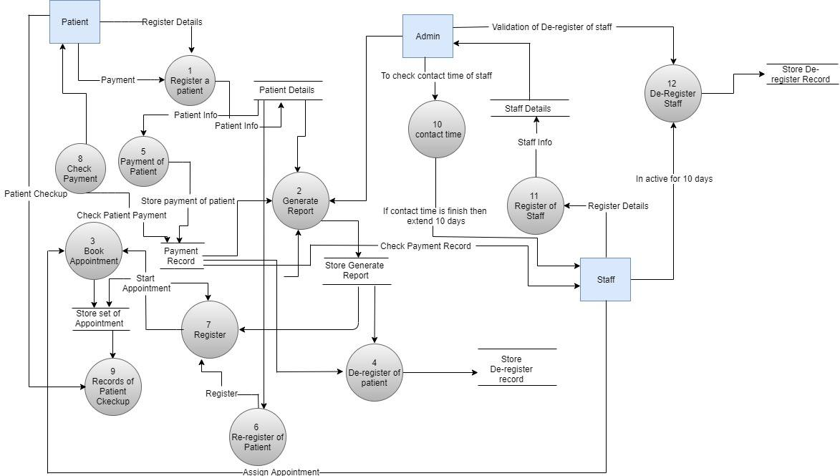

Figure 18: Data Flow Diagram of Darpan Dental Home Application

**Diagram Description**

Here, in the figure it describes the overall system of Darpan Dental Home Application. In the figure it shows that, it consists of three factors that are Admin, Staff and Patient. The external entities and a main entity (Admin) are shown using rectangular box, process is shown using circle and data flows are shown using arrow lines.

In the figure, Patient input their information for the appointment, payment amount and register themselves in the clinic in which that information is stored in Patient Details and Payment Details. Also, after the registration, patient can set their appointment date and time. If appointment is fixed but the Patient are unable to attend the clinic for six months, then the auto reminder message is sent to the patient. The username and password for the patients will be given by admin after registration in the clinic.

Admin checks all the details of the staff like their appointment and the payment of the patients. Also, admin generates the report of the patients. And if anyone want to register for staff then he/she must input their details in the system and the details would be checked and verified by the admin. After verification, the admin provides username and password to the staff. If any unusual things happen then, the admin can de-register the staff and patient too. In the context of contract termination, the staff will get 10 days more for extending the contract then he/she will be de-register automatically.

### **2.2.3 Entity Relationship Diagram:**

An Entity Relationship Diagram is a graphical representation that shows the relationship among entity sets. Typically, it is used in computing regarding the organization of data within database or information systems. As the entity is defined as a piece of data or an object or a concept about which data is stored.

(webopedia, 2020)

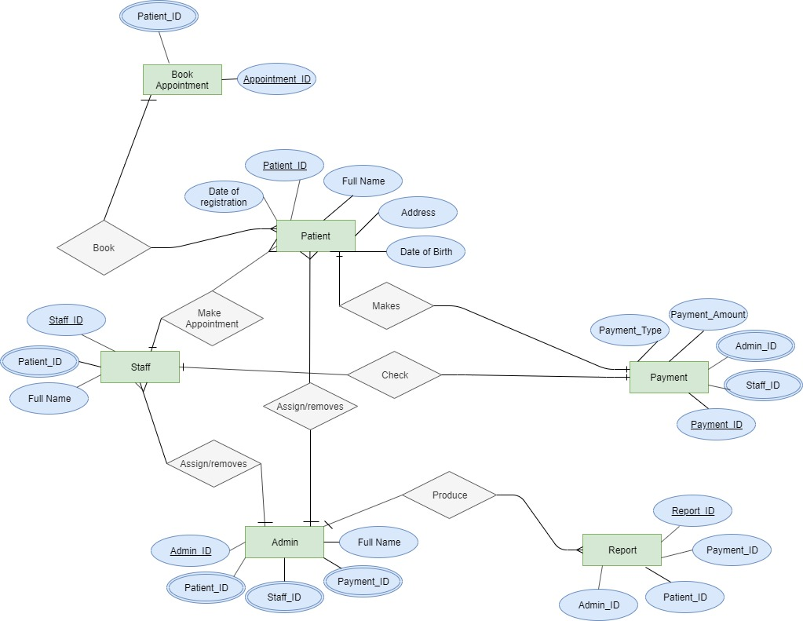

Figure 19: Entity Relationship Diagram of Darpan Dental Home Application

In above figure, it shows Entity Relationship Diagram of Darpan Dental Home Application. It describes all the relation among the entities.

Here are the inner and external entities which are used in the ERD with their attributes are as follow:

1. **Entity:**

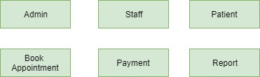

Figure 20: Entities used in Entity Relationship Diagram

1. **Attributes:**

* **Admin:** Admin_ID, Full Name, Staff_ID, Payment_ID, Patient_ID.

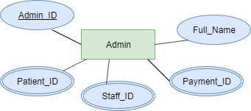

Figure 21: Entity Admin and its attributes

* **Patient:** Patient_ID, Full Name, Address, Date of Birth, Date of Registration.

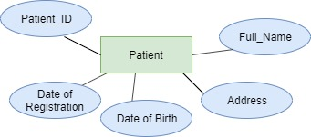

Figure 22: Entity Admin and its attributes

* **Staff:** Staff_ID, Patient_ID, Full Name.

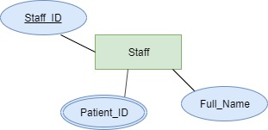

Figure 23: Entity Staff and its attributes

* **Report:** Report_ID, Payment_ID, Patient_ID, Admin_ID.

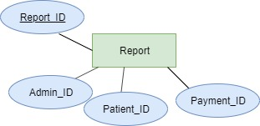

Figure 24: Entity Report and its attributes

* **Payment:** Payment_ID, Staff_ID, Admin_ID, Payment_Amount, Payment_Type.

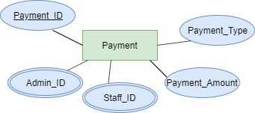

Figure 25: Entity Payment and its attributes

* **Book Appointment:** Patient_ID, Appointment_ID.

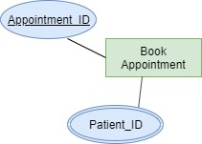

Figure 26: Entity Book Appointment and its attributes

### **2.2.4 Data Dictionary:**

A data dictionary can be defined as a file or a set of files that contains a database’s metadata. It consists of records about other objects is the database, like data ownership, data relationships to other objects, and other data. The data dictionary is invisible to most database users, only database administrators interact with the data dictionary.

Generally, the data dictionary contains information about names of all the database tables and their schemas and their details, physical information of table such as where they are stored and how, table constraints like primary key attributes, foreign key information, and information about the database views that are visible.

(tutorialspoint, 2020)

The data dictionary table of the Darpan Dental Home Application are as follow:

1. **Patient Table**

Table 15: Data Dictionary of Patient table

|  |  |  |  |  |
| --- | --- | --- | --- | --- |
| **Column** | **Data Type** | **Data Format** | **Description** | **Example** |
| **Patient_ID** | Varchar (7) | PA00 | Primary key of a Patient table | PA01 |
| **Full_Name** | Varchar (40) | XXXX | Full Name of Patient | Tej Narayan Chaudhary |
| **Date_Of_Birth** | Varchar (20) | YY/MM/DD | Date Of Birth of Patient | 1997/01/07 |
| **Date of Registration** | Varchar (20) | YY/MM/DD | Date of registration of patient | 2019/1/25 |
| **Address** | Varchar (30) | XXXX | Address of the Patient | Itahari |

1. **Record Table**

Table 16: Data Dictionary of Record table

|  |  |  |  |  |
| --- | --- | --- | --- | --- |
| **Column** | **Data Type** | **Data Format** | **Description** | **Example** |
| **Record_ID** | Varchar (7) | RE00 | Primary Key of Patient Record table | RE01 |
| **Reg_ID** | Varchar (10) | REG00 | Primary key of Registration table acts as a reference in Patient Record table | REG01 |
| **User_name** | Varchar (40) | XXXX | Username of Patient | Tej Narayan Chaudhary |
| **Password** | Varchar (20) | ******** | Password of Patient | TNC@1# |

1. **Register Table for Patient**

Table 17: Data Dictionary of Register table for Patient

|  |  |  |  |  |
| --- | --- | --- | --- | --- |
| **Column** | **Data Type** | **Data Format** | **Description** | **Example** |
| **Reg_ID** | Varchar (10) | REG00 | Primary key of Registration table | REG01 |
| **Date_Of_Registration** | Varchar (20) | YY/MM/DD | Registration Date of Patient | 2020/01/10 |
| **Patient_ID** | Varchar (7) | AN00 | Primary key of Patient table act as a references in Registration table | PA01 |

1. **Admin Table**

Table 18: Data Dictionary of Admin Table

|  |  |  |  |  |
| --- | --- | --- | --- | --- |
| **Column** | **Data Type** | **Data Format** | **Description** | **Example** |
| **Admin_ID** | Varchar (7) | AD00 | Primary key of Admin table | AD01 |
| **Full_Name** | Varchar (40) | XXXX | Fullname of Admin | Bibek Bhattarai |
| **Record_ID** | Varchar (7) | RE00 | Primary key of Patient Record table acts as a references in Admin Table | RE01 |

1. **Report Table**

Table 19: Data Dictionary of Report Table

|  |  |  |  |  |
| --- | --- | --- | --- | --- |
| **Column** | **Data Type** | **Data Format** | **Description** | **Example** |
| **Report_ID** | Varchar (7) | REP01 | Primary key of Report table | REP01 |
| **Description** | Varchar (256) | XXXX | Description of Report |  |
| **Admin_ID** | Varchar (7) | AD00 | Primary key of Admin table act as a references in Report table | AD01 |
| **Record_ID** | Varchar (7) | RE00 | Primary key of Record ID | RE01 |

1. **Staff**

Table 20: Data Dictionary of Staff Table

|  |  |  |  |  |
| --- | --- | --- | --- | --- |
| **Column** | **Data Type** | **Data Format** | **Description** | **Example** |
| **Staff_ID** | Varchar (7) | S001 | Primary key of Staff table | S001 |
| **Full_Name** | Varchar (40) | XXXX | Fullname of the Staff | Devil Devkota |
| **Date_Of_Birth** | Varchar (7) | YY/MM/DD | Date of Birth of Staff | 1996/08/30 |
| **Address** | Varchar (7) | XXXX | Address of the Staff | Itahari |
| **Age** | Int | 000 | Age of the Staff | 23 |
| **Salary** | Int | 00000 | Amount paid to Staff | 20000 |
| **Payment_Type** | Varchar (20) |  | Payment Type of Staff | Cheque |

1. **Staff Registration**

Table 21: Data Dictionary of Staff Registration

|  |  |  |  |  |
| --- | --- | --- | --- | --- |
| **Column** | **Data Type** | **Data Format** | **Description** | **Example** |
| **Reg_ID** | Varchar (10) | REGS00 | Primary key of Staff Registration table | REGS001 |
| **Staff_ID** | Varchar (7) | S000 | Primary key of Staff table act as a reference in Staff Registration table | S001 |
| **Admin_ID** | Varchar (7) | AD00 | Primary key of Admin table act as a reference in Staff Registration table | AD01 |
| **Date_Of_Registration** | Varchar (20) | YY/MM/DD | Registration date of Staff | 2020/01/01 |

1. **Contract Time**

Table 22: Data Dictionary of Contract Table

|  |  |  |  |  |
| --- | --- | --- | --- | --- |
| **Column** | **Data Type** | **Data Format** | **Description** | **Example** |
| **Contract_ID** | Varchar (20) | YY/MM/DD | Primary key of Contact Time table | 2020/01/05 |
| **Duration** | Varchar (12) | Hours | Duration of Contact Time | 2 Hours |
| **Staff_ID** | Varchar (7) | S000 | Primary key of Staff table act as a reference in Contact Tome table | S001 |

1. **Restriction Table**

Table 23: Data Dictionary of Restriction Table

|  |  |  |  |  |
| --- | --- | --- | --- | --- |
| **Column** | **Data Type** | **Data Format** | **Description** | **Example** |
| **Restricted_ID** | Varchar (20) | RX000 | Primary key of Restriction table | RX001 |
| **Contact_ID** | Varchar (20) | YY/MM/DD | Primary key of Contact Time table act as a references in Restriction table | 2020/01/05 |

1. **Book Appointment Table**

Table 24: Data Dictionary of Book Appointment Table

|  |  |  |  |  |
| --- | --- | --- | --- | --- |
| **Column** | **Data Type** | **Data Format** | **Description** | **Example** |
| **Appointment_ID** | Varchar (10) | APP00 | Primary key of Book Appointment table | APP01 |
| **Appointment_Description** | Varchar (30) | XXXXX | Description of Appointment |  |
| **Patient_ID** | Varchar (7) | PA00 | Primary key of Patient table act as a reference in Book Appointment table | PA01 |
| **Assign_Treatment** | Varchar (30) | XXXXX | Registration date of Staff | 2020/01/01 |
| **Staff_ID** | Varchar (7) | S000 | Primary key of the Staff table act as a references in Book Appointment Table | S001 |

1. **Deadline Table**

Table 25: Data Dictionary of Deadline Table

|  |  |  |  |  |
| --- | --- | --- | --- | --- |
| **Column** | **Data Type** | **Data Format** | **Description** | **Example** |
| **Payment_ID** | Varchar (7) | PAY00 | Primary key of Deadline table | PAY01 |
| **Payment_Date** | Varchar (20) | YY/MM/DD | Date of Payment | 2020/01/06 |
| **Payment_expire_Date** | Varchar (20) | YY/MM/DD | Expiry date of Payment | 2021/01/05 |
| **Patient_ID** | Varchar (7) | YY/MM/DD | Primary key of Patient table act as a references in Deadline table | PA01 |

## **2.3 DESIGN SPECIFICATION**

### **2.3.1 Structure Chart of Darpan Dental Home Application**

Structure Chart is a graphical representation in hierarchical structure of model. It shows lowest level of functional modules, describes functions and sub functions of each module of a system to a greater detail. In the structure chart components are read from top to bottom and left to right.

(Geeks for Geeks, 2020)

The structure chart of Darpan Dental Home Application is given below:

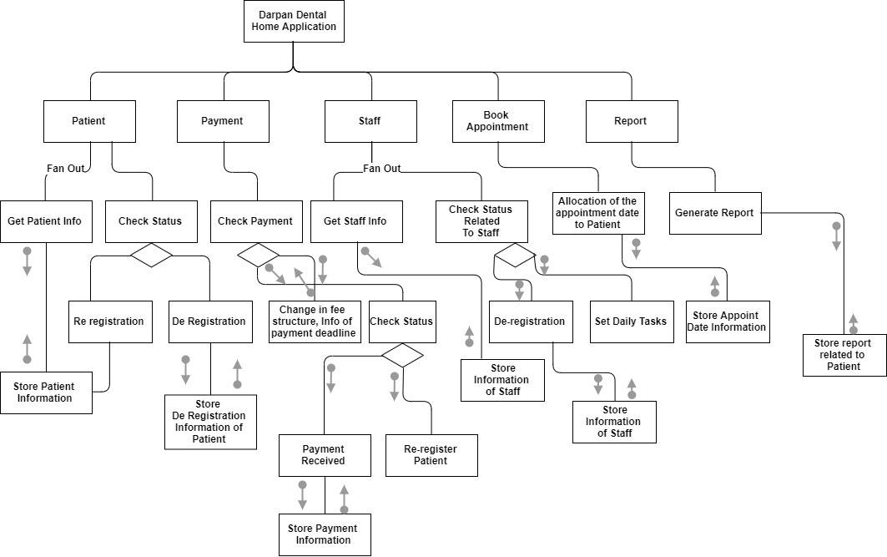

Figure 27: Structure chart of Darpan Dental Home Application

## **2.4 ASSIGNMENT DIARY**

**Assumptions**

There were many assumptions built for creating this project. Initially, assumptions were made for the patient who should register his or her name and their basic information for the appointment in the clinic for the treatment. If they could not attend the clinic for the six months of their registration, the system will send a reminder for the patient. Here, they can register their name and upgrade the follow up time. Here, the staff of the hospital manages the appointment and the follow up of the patient. Staffs also should manage the payment and payment type done by the patient.

**Group Meeting Dates**

Table 26: Group Meeting Date Table

|  |  |
| --- | --- |
| Date | Meeting agenda |
| 2020-1-2 | We discussed coursework and its scenario. |
| 2020-1-3 | We discussed, researched and made figures related to context diagram, DFD, ERD and structure chart of system to be made. |
| 2020-1-5 | We divided our working responsibility individually. |
| 2020-1-7 | We made several researches for the coursework to complete it and conclude it. |
| 2020-1-9 | We finalize our coursework with our group work and effort from all the members. |

**Group Responsibilities:**

Table 27: Group responsibilities Table

|  |  |
| --- | --- |
| Member Name | Completed Work |
| Girija Tamang | Structure chart, Payment of Patient function, DFD fragments, Summary |
| Rikesh Niroula | De-register Staff function, DFD diagram, Document Design |
| Samip Danuwar | Event list, Book Appointment function, Context diagram |
| Sushan Adhikari | Register a Patient function, Assignment Diary, Introduction |
| Tej Narayan Chaudhary | ERD diagram, Data dictionary, Generate report function |

# **INDIVIDUAL TASK**

## **3.1 Register a Patient Function**

**STUDENT NAME: SUSAN ADHIKARI**

**STUDENT ID: 18028947**

### **3.1.1 Environmental Module Specification**

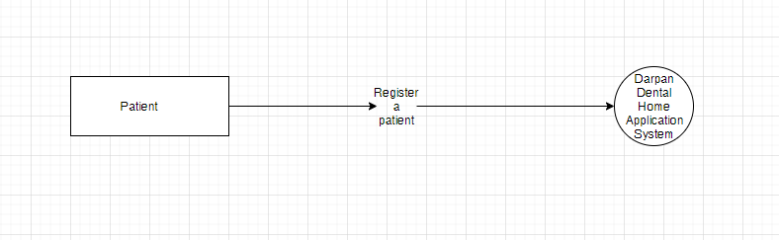

Figure 28: Context Diagram of Register of Patient

Here, contextual diagram is being made. In this diagram, there are two parties. One is patient and the next is Darpan Dental Home Application System. In this diagram, data flow of registration of patient is depicted. Patient gives the basic information about him or her to this system which directly goes to Darpan Dental Home Application. He or she can easily register name through this system.

### **3.1.2 Internal Module Specification**

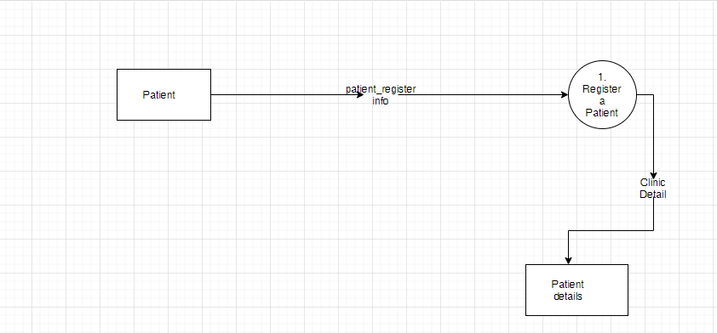

Figure 29: Level 1 DFD of Register of Patient

The figure which is above depicts the level 1 of DFD fragments of process ‘Register a Patient’. In this process, the patient gives the information of their details of registration. That information ar­e stored in a patient details. From this process, the patient even can get the details of clinic.

### **3.1.3 Level 2 DFD**

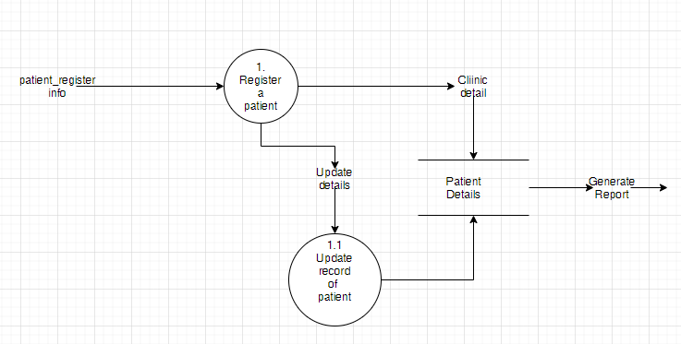

Figure 30: Level 2 DFD of Register of Patient

Above figure shows the level 2 of DFD of patient registration system. The process involve in registration of patient is shown here. Initially, the patient include their information and details for the registration in process 1. If the patient wants to upgrade their detail the second process is generated.

### **3.1.4 Design Specification**

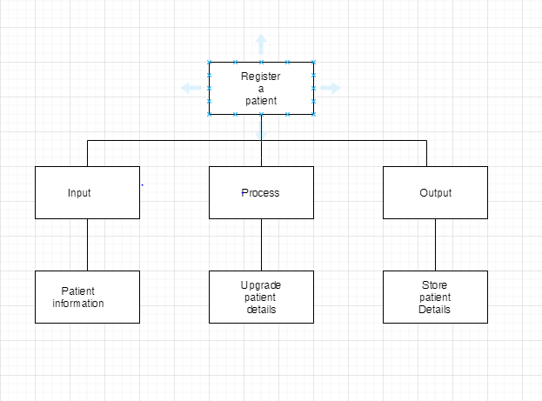

Figure 31: Structure Chart of Register of Patient

This figure shows the structured chart for registration of patient. There are three process include in it. They are input, process and output. Initially, the information of the patient is included. Secondly, the details and the information of the patient are upgraded and finally, this system stores the details of the patient.

**Module Name:** Register a Patient

**Structured English**

This process is to register a patient by the patient entity. Sitting on this process, patient can upgrade patient details and stored in Patient Details box. This process starts with a patient. Patient details is included for the registration. Later on, the details of patient is stored in patient details box. The details can be updated if they need to update it. It reminds the patient if they do not come to hospital even after the six months of register. Here, the input parameter is register, output parameter is registering a costumer. None of the global variable and local variables are used which is called by the patient.

## **3.2 Payment of Patient Function**

**STUDENT NAME: GIRIJA TAMANG**

**STUDENT ID: 18030995**

### **3.2.1 Environmental Module Specification**

A context-level diagram is drawn to define and clarify the boundaries of the software, also known as 0 Level Data Flow Diagram. The Context Diagram shows the system under consideration as a single high-level process and then shows the relationship that the system has with other external entities such as systems, organizational groups, external data stores, etc.

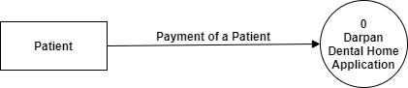

Figure 32: Context Diagram of Payment of Patient

In this above diagram, there are two parties. One is patient and the next is Darpan Dental Home Application. In this diagram, data flow of payment of patient is depicted. This function is performed by the Patients. The patient’s payment information is recorded in a system which directly goes to Darpan Dental Home Application.

### **3.2.2 Internal Module Specification**

In 1-level DFD, the context diagram is broken down into multiple bubbles / processes. At this level, the main functions of the system are illustrated and the 0-level DFD high-level process is subdivided into sub processes. This level 1 DFD looks at the payment process of patient with more detail than a 0 level DFD.

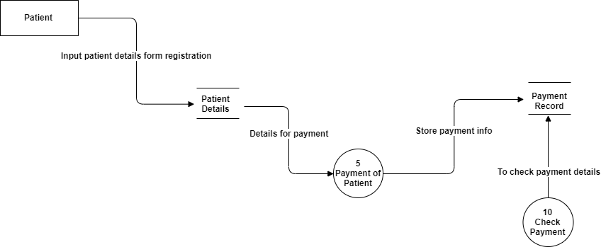

Figure 33: Level 1 DFD of Payment of Patient

From the above figure, we can see that a patient register first in the system before payment process then patient payment information is stored in payment record database after executing payment of patient process and likewise the system checks payment details through payment record database with the help of check payment process.

### **3.2.3 Level 2 DFD**

2-level DFD moves a step further into sections of 1-level DFD. It can be used to schedule or document specific / necessary details about the operation of the system. This level 2 DFD looks at the payment process of patient involved with  
more detail than a level 1 DFD.

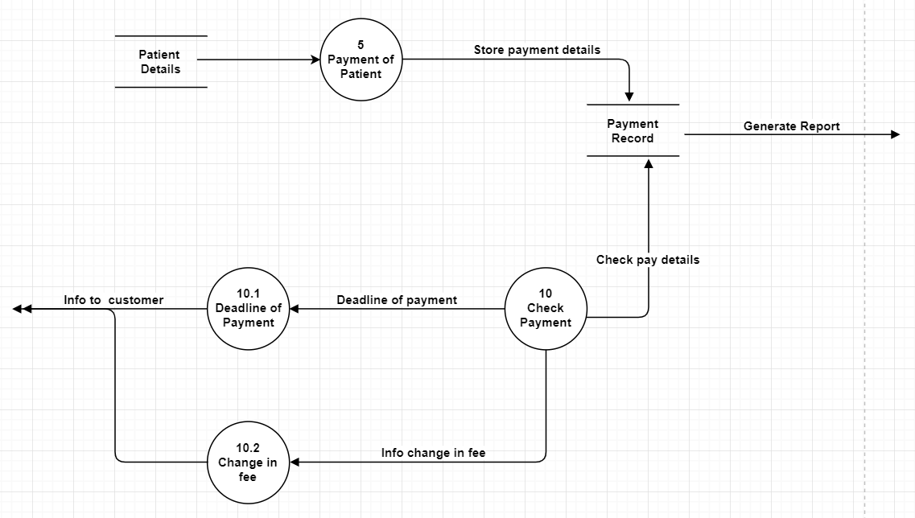

Figure 34: Level 2 DFD of Payment of Patient

From the above figure we can see that payment of patient has been divided into four process, which are payment of patient, check payment, change in fee, deadline of payment. In the first “payment of patient” process is checked from the patient details database then the patient execute the payment process and its details are stored on payment record database linking with another process “check payment” for checking payment details as well as for informing patient about “deadline of payment” and “change in fee structure”.

### **3.2.4 Design Specification**

The Structure Chart reflects the hierarchical structure of the modules. It breaks down the entire system into the lowest functional modules, describes the functions and sub-functions of each system module in more detail.

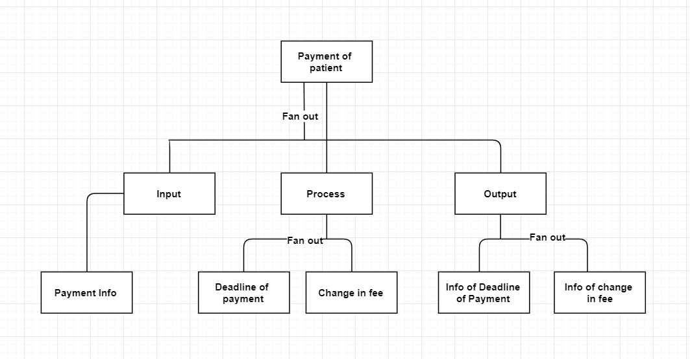

Figure 35: Structure Chart of Payment of Patient

The above figure shows the sub function of the payment of the patient. Here, payment info is recorded and processed. As the output the patient is informed about the deadline of payment and change in fee.

**Module Name:** Payment of Patient

**Input data flow:** Patient details

**Output:** Patient Report

**Type of process:** online

**Process:**

This process is required for ‘payment process of a patient’ by the patient. Staying on Payment of a Patient process patient payment details are recorded in “payment record database” and for informing patient about deadline of payment and change in fee “check payment process” is executed.

**PSEUDO CODE**

Start Payment of a patient

Input patient details for payment

Store payment details in payment record database

Check payment details by system to inform about the deadline of patient and

Change in fee

Inform customer about deadline of payment and change in fee

Stop

Input Parameters: Payment

Output Parameters: Payment of a Patient report

Global variables: none

Local variables: none

Calls: Payment Record

Called By: Patient

### **3.3 Book Appointment**

**STUDENT NAME: SAMIP DANUWAR**

**STUDENT ID: 18028965**

### **3.3.1 Environmental Module Specification**

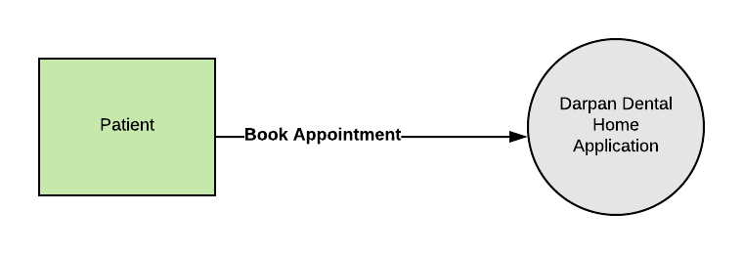

Figure 36 Book Appointment Context Diagram

This figure shows context diagram of ‘Book Appointment’. This type of work is done by patient. The patient can make own book appointment which is already in task of system they desire. It is directly linked with Darpan Dental Home Application.

### **3.3.2 Internal Module Specification**

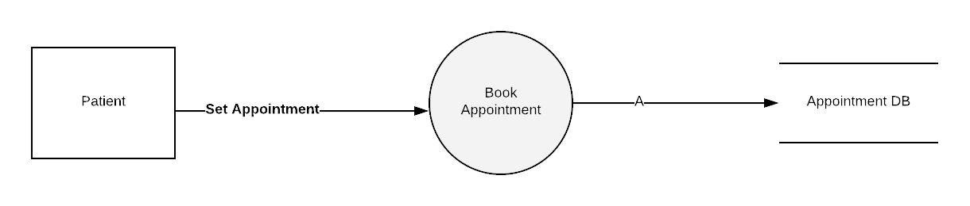

Figure 37 Book Appointment Level 1 DFD

The figure above shows the level 1 of data flow diagram of book appointment where patient set the appointment themselves. Here, the record is kept on appointment database.

### **3.3.3 Level 2 DFD**

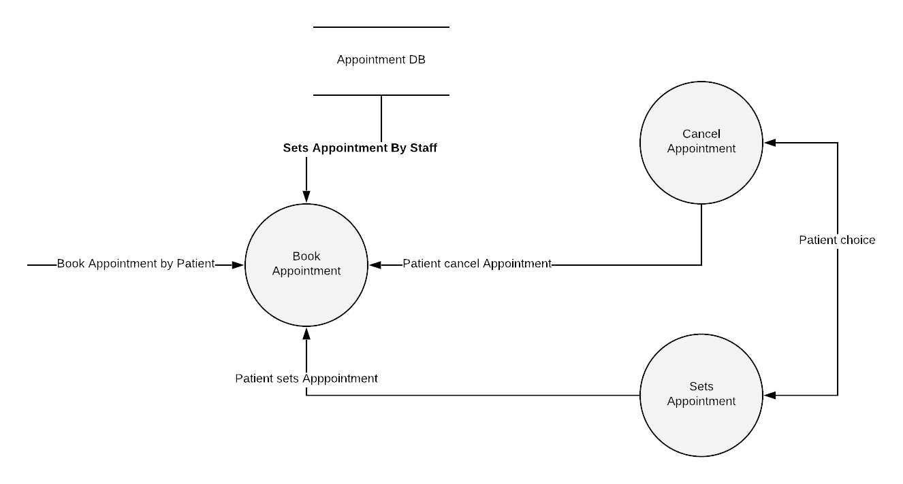

Figure 38 Book Appointment Level 2 DFD

The above figure depicts the level 2 of Book Appointment. This shows the process involves in book appointment system. In this phase, the patient can cancel as well as set the appointment themselves as it is upon their choice. Here, the appointment system is created by the staff.

### **3.3.4 Design Specification**

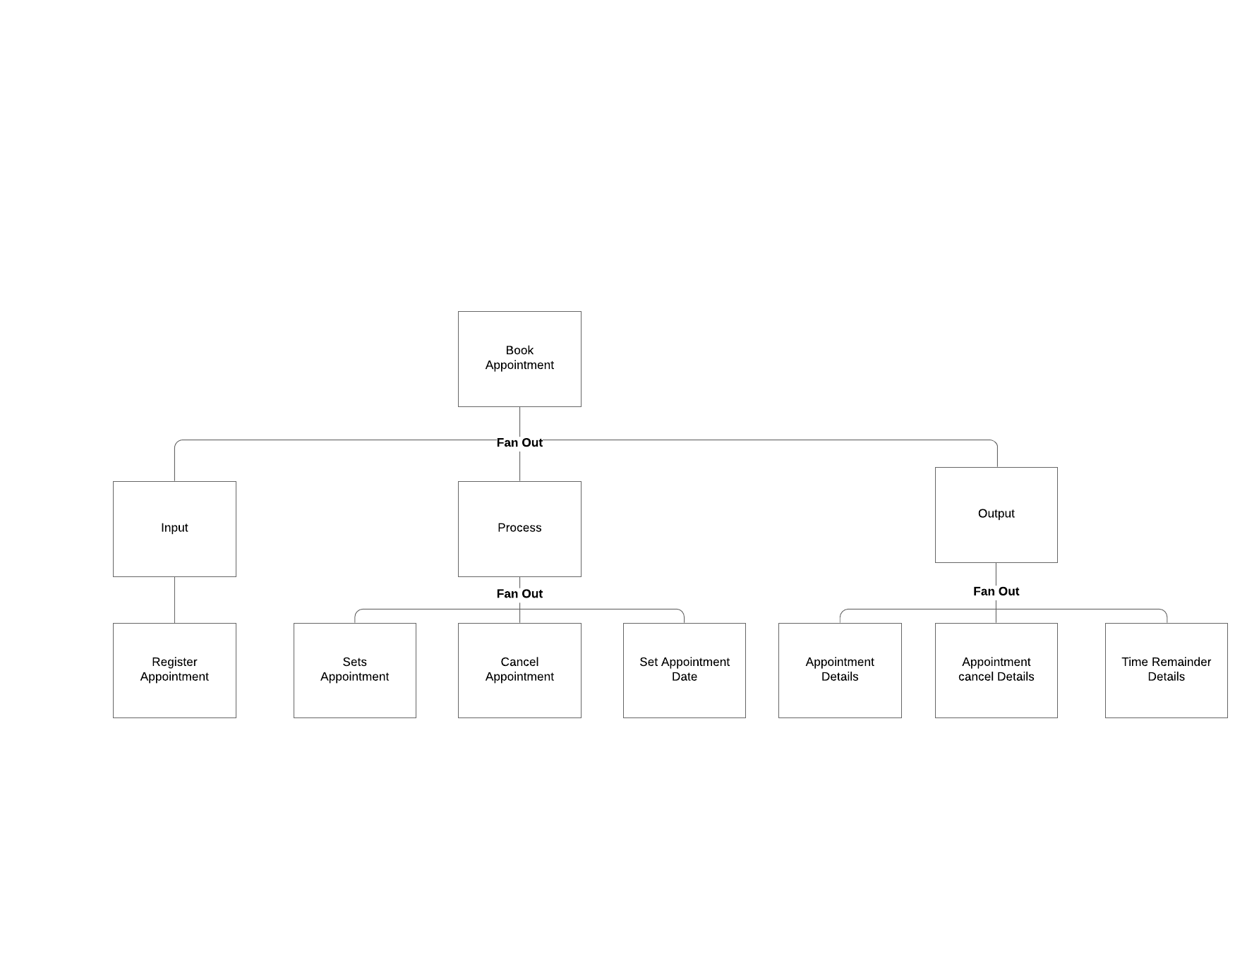

Figure 39 Book Appointment Design Specification

This figure shows the structure chart of book appointment. Here, there are three process which includes input, process and output. The patient can set appointment date and cancel appointment as their desire.

**Module Name:** Book Appointment

**PSEUDO CODE**

This process is Book Appointment. Sitting on this process, the patient can set the date of appointment and also cancel them if is needed. Staff assign the daily task. It begins with the book appointment. Here, the appointment is also set by the patient an also the cancellation of appointment if they want. It sets the reminder if the patient does not visit hospital after the six months of registration. Here, the input parameter is registration and output variable are update registration. It is called by the patient.

### **3.4 De-Register Staff**

**STUDENT NAME: RIKESH NIROULA**

**STUDENT ID: 18028923**

### **3.4.1 Environmental Module Specification**

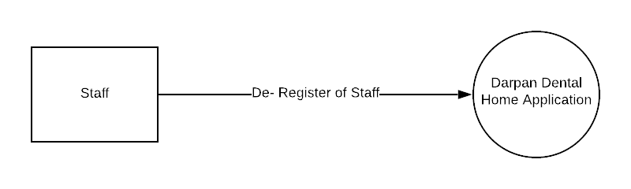

Figure 40 De-Register Staff Context Diagram

The figure above shows the contextual diagram of de-register of staff. This function is created by the staffs. Here, there is direct relationship between staffs and Darpan Dental Clinic Application.

### **3.4.2 Internal Module Specification**

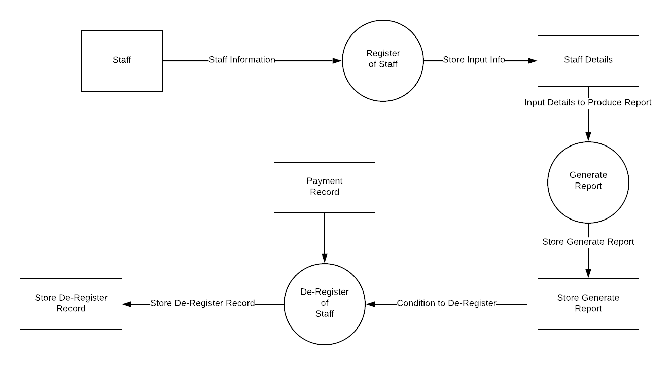

Figure 41 De-Register Level 1 DFD

The above figure shows the Level 1 DFD fragment of process “De-register of Staff". However, first Staff register with this formality generate report is created then looking after generate report system makes decision to de-register the Staff.

### **3.4.3 Level 2 DFD**

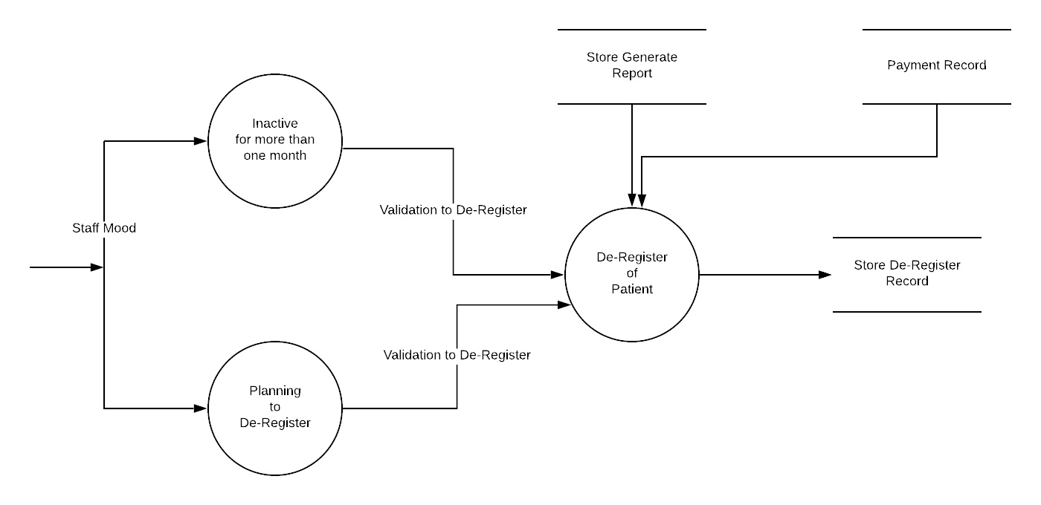

Figure 42 De-Register Staff Level 2 DFD

The figure above is level 2 of DFD of De-register staff. This process shows the involvement of staff, whereas de-register of staff process is linked with the generate report and payment record as long as system analysis staff properly.

### **3.4.4 Design Specification**

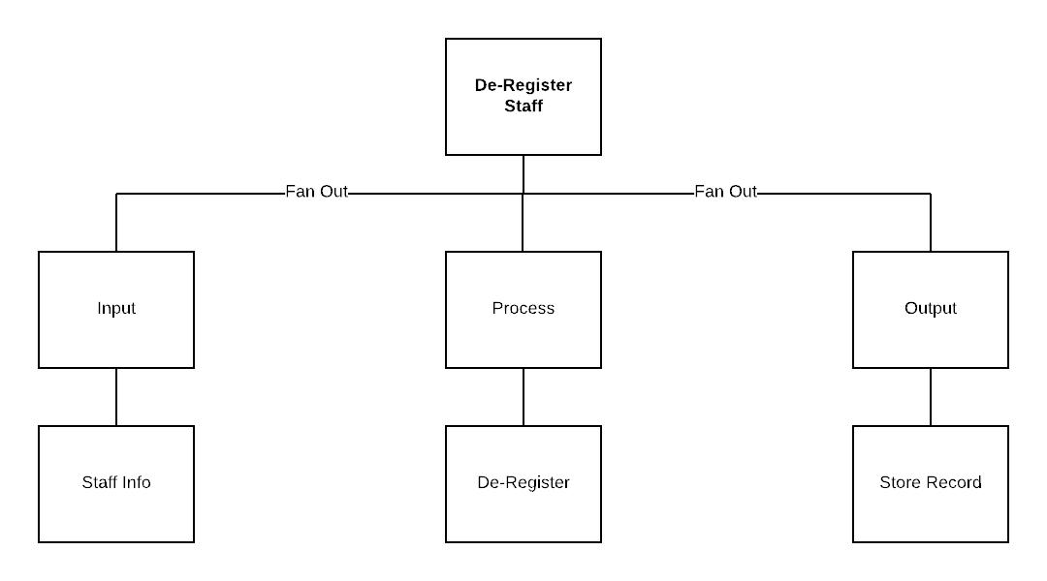

Figure 43 De-Register Staff Design Specification

The figure above shows the structured chart of the de-registration of the staff. Input, process and output are the three-process involved here.

**Module Name:** De-Register of Customer

**PSEUDO CODE**

This process is full guideline to the information of activities done by the staffs. It begins with the registration of patient. It generates report, keeps the record of payment, the regular patient and the decision of the patient. It includes input parameter as report and record, output parameter as de-register of staff. Here, none of the global and local variable are used. It is called by system.

### **3.5 Generate Report of Patient**

**STUDENT NAME: TEJ NARAYAN CHAUDHARY**

**STUDENT ID: 18028969**

### **3.5.1 Environmental Module Specification**

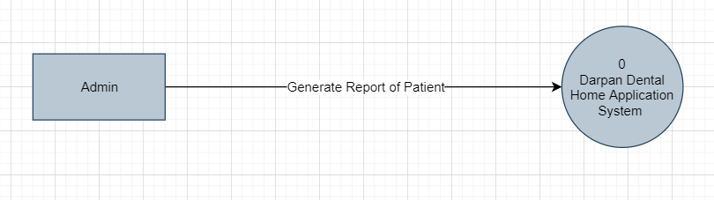

Figure 44 Generate Report of Patient Context Diagram

The above figure shows the context diagram of a function “Generate Report of customer". This function is performed by the admin only. The admin look generate report which are created by combination of “Patient Details”, “Payment record” and “Store set of tasks” of system.

### **3.5.2 Internal Module Specification**

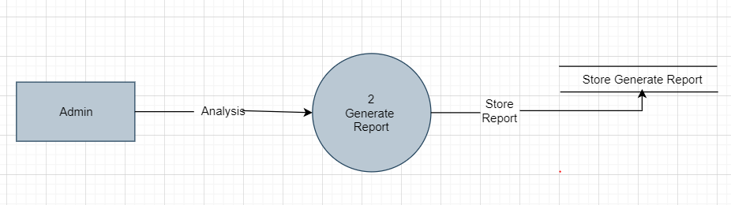

Figure 45 Generate Report Level 1 DFD

The above figure shows the level 1 DFD fragment of process “Generate Report of Patient ". However, an admin looked generate report then it while direct stored in “Store Generate Report” storage container.

### **3.5.3 Level 2 DFD**

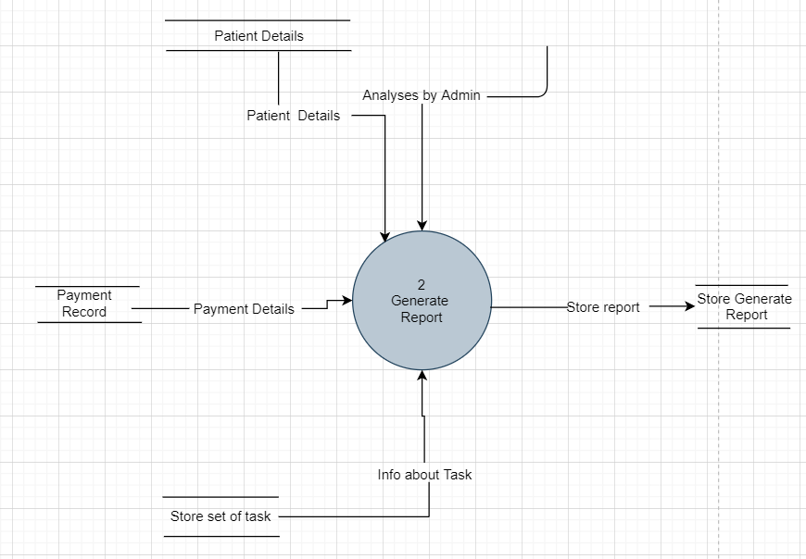

Figure 46 Generate Report Level 2 DFD

The above figure shows the level 2 DFD. It shows the process involved in Generate Report of Patient. Whereas, system create generate report by the combination of “Patient Details”, “Payment Record” and “Store set of tasks” which are totally analysis by admin then it stored generate report in storage container.

**3.5.4 Design Specification**

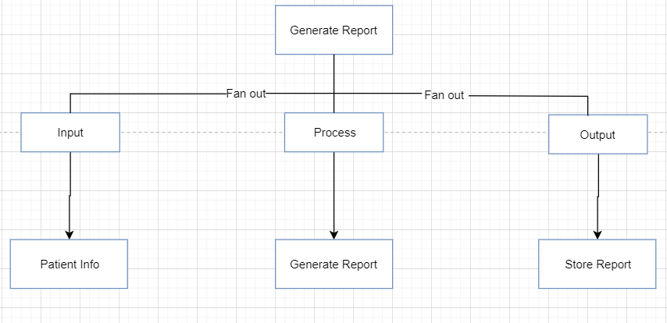

Figure 47 Generate Report of Patient Design Specification

The following figure shows the sub function of the generate report of the Patient. Patient info arrives as an input, generates report and the generated report is stored as a output.

**Module Name:** Generate Report of Patient

Purpose: This process is to Generate Report by the detail’s information of Patient regarding their stored information i.e. “Patient Details”, “Payment Record” and “Store set of tasks”

**PSEUDO CODE**

BEGIN Generate Report of Patient

Patient Details

Payment Record

Set of tasks

All the details information created generate report

Which is analysis by admin

END

INPUT PARAMETERS: report

OUTPUT PARAMETERS: Generate Report

GLOBAL VARIABLES: None

LOCAL VARIABLES: None

CALLS: Generate Report of Patient

CALLED BY: Admin

# **SUMMARY**

The project is about formulating the Darpan Dental Home Application with the maintaining the records of the patient who wills for the appointment in the hospital. There were many types of diagrams which were created to shows the data process and data flows within the entities. For the specification of diagram and design substantial part, the system using structured approach is taken.

Context level diagram is designed illustrating the level 0 view of the system. The relationship between the entities is also shown here. Here, in level 1 and level 2 of the relationship between the process and the flow of data is shown here. Here, the relationship between the entities are shown by making the ER-Diagram. Here, pseudocode is written as structured English language as it is the language to describe the overall process of the data flow in each diagram.

This project is featured with the two-part group and individual. Each function describes the diagram. Assignment diary is also created. The assumption of the whole work is also shown in this project.

# **REFERENCES**

Geeks for Geeks, 2020. *Software Engineering | Structure Charts.* [Online]   
Available at: https://www.geeksforgeeks.org/software-engineering-structure-charts/  
[Accessed 7 January 2020].

MSCIT Study Material, 2011. *Context diagrams.* [Online]   
Available at: https://www.cs.uct.ac.za/mit_notes/software/htmls/ch06s06.html  
[Accessed 6 January 2020].

techopedia, 2020. *Data Dictionary.* [Online]   
Available at: https://www.techopedia.com/definition/27752/data-dictionary  
[Accessed 7 January 2020].

tutorialspoint, 2020. *What is Data Dictionary.* [Online]   
Available at: https://www.tutorialspoint.com/What-is-Data-Dictionary  
[Accessed 7 January 2020].

Visual Paradigm, 2020. *What is Data Flow Diagram?.* [Online]   
Available at: https://www.visual-paradigm.com/guide/data-flow-diagram/what-is-data-flow-diagram/  
[Accessed 6 January 2020].

webopedia, 2020. *entity-relationship diagram (model).* [Online]   
Available at: entity_relationship_diagram  
[Accessed 6 January 2020].